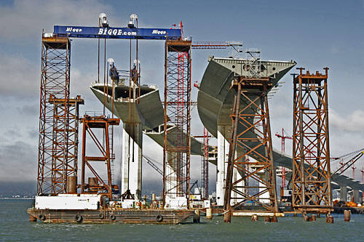
Problem: You are part of a group of civil engineers that has been chosen to develop a bridge for a new site. With your assigned team, you must complete the model within two weeks and it must meet all of the requirements listed below.
Specifications:
- The bridge must span 12 inches
- The bridge should be 2 – 4 inches tall
- A small cube (1 inch sides) should be able to pass completely through the bridge
- The bridge must support at least 5 kg of weight
Materials:
- 100 Popsicle Sticks
- Wood glue
Constraints:
- The bridge cannot be attached to the ground or any other supports (books, etc.) in any way
- The bridge must be portable
- Only the materials provided may be used; glue may only be used to secure joints and not to reinforce the structure
Deliverables:
Plans due, including a full size top/ road view and a side view:__________________
Bridge testing:_____________________
Rubric
Category | Needs improvement (0-70%) | Basic  (70%-80%) | Good  (80%-90%) | Excellent  (90%-100%)
Planning | Missing components, not feasible design | Missing details / labels and some components | Missing details / labels | Detailed, labeled sketch including all components; feasible design
Construction | Missing 2 or more designs and not stable construction | Missing 2 specifications OR not stable construction | Missing 1 specification | Stable, well-constructed, includes all specifications
Testing | Holds less than 2 kg | Holds 2kg – 3 kg | Holds 3kg – 4 kg | Holds more than 4 kg
Requirements | 4 or more requirements not met | 3 requirements not met | 1-2 requirements not met | All requirements met

