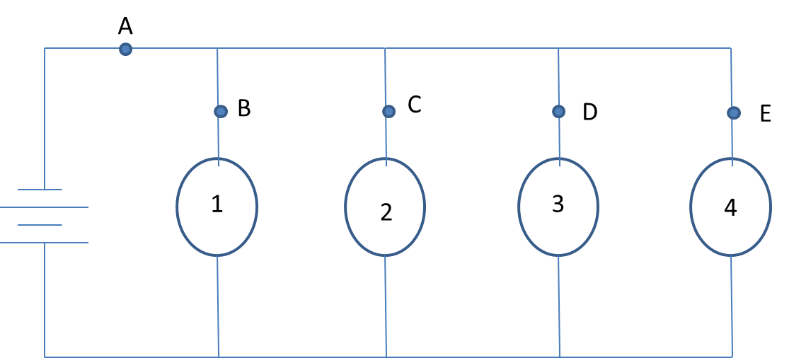
CIRCUIT 1
- Sketch this circuit in your lab notebook.
- Fill in and copy each of the following predictions in your lab notebook:
I predict that when you open a switch at A, lightbulbs (1, 2, 3, 4) will light up.
I predict that when you open a switch at B, lightbulbs (1, 2, 3, 4) will light up.
I predict that when you open a switch at C, lightbulbs (1, 2, 3, 4) will light up.
I predict that when you open a switch at D, lightbulbs (1, 2, 3, 4) will light up.
I predict that when you open a switch at E, lightbulbs (1, 2, 3, 4) will light up.

Next, test your predictions with either a lab kit or online simulation. Record your observations.
When we opened a switch at A, lightbulbs (1, 2, 3, 4) lit up.
When we opened a switch at B, lightbulbs (1, 2, 3, 4) lit up.
When we opened a switch at C, lightbulbs (1, 2, 3, 4) lit up.
When we opened a switch at D, lightbulbs (1, 2, 3, 4) lit up.
When we opened a switch at E, lightbulbs (1, 2, 3, 4) lit up.

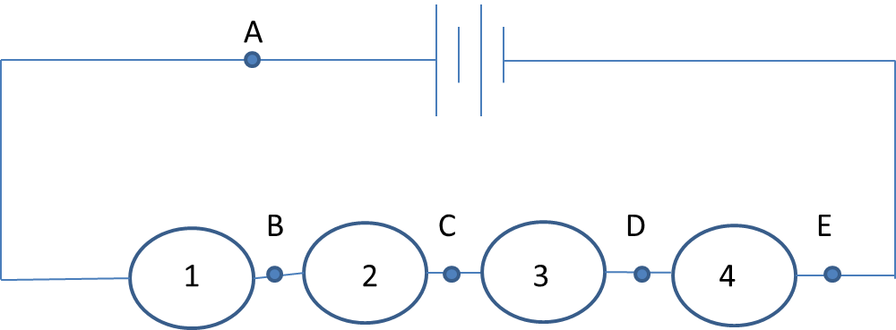
CIRCUIT 2
- Sketch this circuit in your lab notebook.
- Fill in and copy each of the following predictions in your lab notebook:
I predict that when you open a switch at A, lightbulbs (1, 2, 3, 4) will light up.
I predict that when you open a switch at B, lightbulbs (1, 2, 3, 4) will light up.
I predict that when you open a switch at C, lightbulbs (1, 2, 3, 4) will light up.
I predict that when you open a switch at D, lightbulbs (1, 2, 3, 4) will light up.
I predict that when you open a switch at E, lightbulbs (1, 2, 3, 4) will light up.

Next, test your predictions with either a lab kit or online simulation. Record your observations.
When we opened a switch at A, lightbulbs (1, 2, 3, 4) lit up.
When we opened a switch at B, lightbulbs (1, 2, 3, 4) lit up.
When we opened a switch at C, lightbulbs (1, 2, 3, 4) lit up.
When we opened a switch at D, lightbulbs (1, 2, 3, 4) lit up.
When we opened a switch at E, lightbulbs (1, 2, 3, 4) lit up.

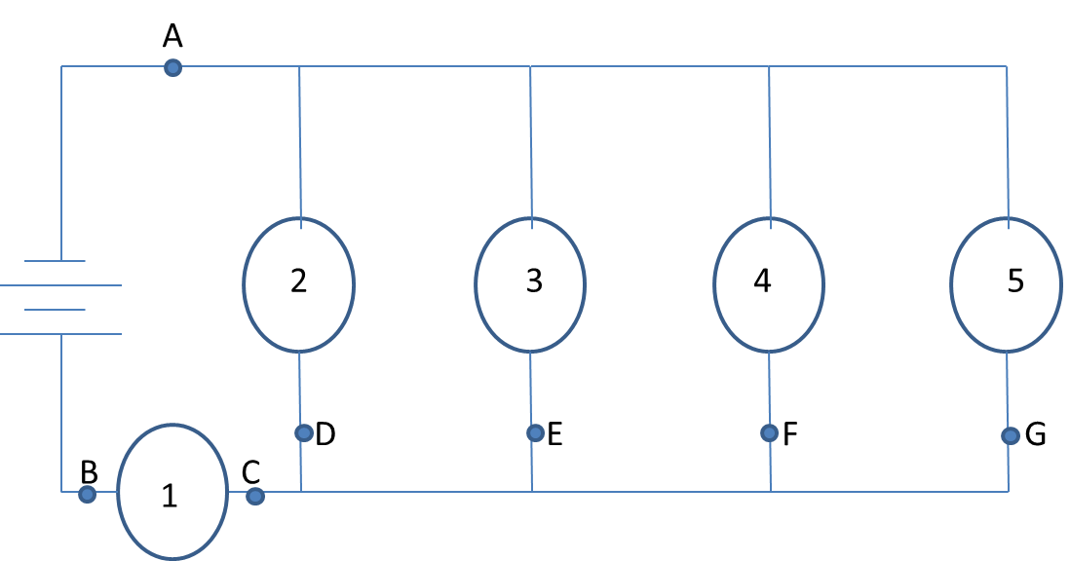
CIRCUIT 3
- Sketch this circuit in your lab notebook.
- Fill in and copy each of the following predictions in your lab notebook:
I predict that when you open a switch at A, lightbulbs (1, 2, 3, 4) will light up.
I predict that when you open a switch at B, lightbulbs (1, 2, 3, 4) will light up.
I predict that when you open a switch at C, lightbulbs (1, 2, 3, 4) will light up.
I predict that when you open a switch at D, lightbulbs (1, 2, 3, 4) will light up.
I predict that when you open a switch at E, lightbulbs (1, 2, 3, 4) will light up.
I predict that when you open a switch at F, lightbulbs (1, 2, 3, 4) will light up.
I predict that when you open a switch at G, lightbulbs (1, 2, 3, 4) will light up.
Next, test your predictions with either a lab kit or online simulation. Record your observations.
When we opened a switch at A, lightbulbs (1, 2, 3, 4) lit up.
When we opened a switch at B, lightbulbs (1, 2, 3, 4) lit up.
When we opened a switch at C, lightbulbs (1, 2, 3, 4) lit up.
When we opened a switch at D, lightbulbs (1, 2, 3, 4) lit up.
When we opened a switch at E, lightbulbs (1, 2, 3, 4) lit up.
When we opened a switch at F, lightbulbs (1, 2, 3, 4) lit up.
When we opened a switch at G, lightbulbs (1, 2, 3, 4) lit up.
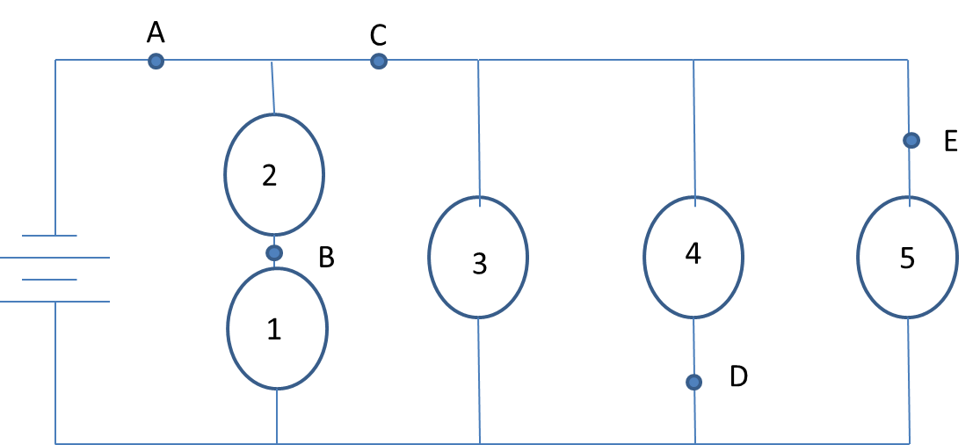
CIRCUIT 4
- Sketch this circuit in your lab notebook.
- Fill in and copy each of the following predictions in your lab notebook:
I predict that when you open a switch at A, lightbulbs (1, 2, 3, 4) will light up.
I predict that when you open a switch at B, lightbulbs (1, 2, 3, 4) will light up.
I predict that when you open a switch at C, lightbulbs (1, 2, 3, 4) will light up.
I predict that when you open a switch at D, lightbulbs (1, 2, 3, 4) will light up.
I predict that when you open a switch at E, lightbulbs (1, 2, 3, 4) will light up.

Next, test your predictions with either a lab kit or online simulation. Record your observations.
When we opened a switch at A, lightbulbs (1, 2, 3, 4) lit up.
When we opened a switch at B, lightbulbs (1, 2, 3, 4) lit up.
When we opened a switch at C, lightbulbs (1, 2, 3, 4) lit up.
When we opened a switch at D, lightbulbs (1, 2, 3, 4) lit up.
When we opened a switch at E, lightbulbs (1, 2, 3, 4) lit up.

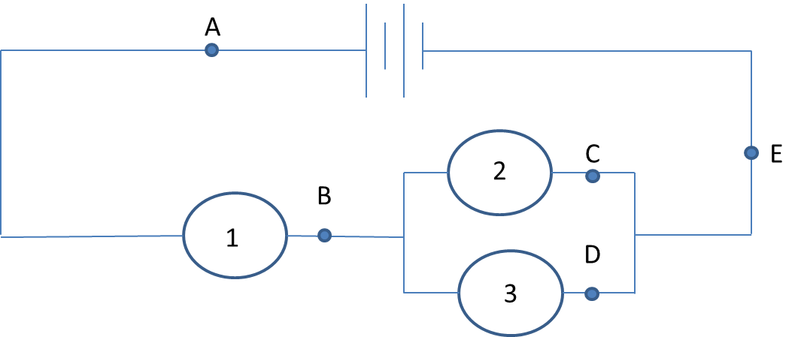
CIRCUIT 5
- Sketch this circuit in your lab notebook.
- Fill in and copy each of the following predictions in your lab notebook:
I predict that when you open a switch at A, lightbulbs (1, 2, 3, 4) will light up.
I predict that when you open a switch at B, lightbulbs (1, 2, 3, 4) will light up.
I predict that when you open a switch at C, lightbulbs (1, 2, 3, 4) will light up.
I predict that when you open a switch at D, lightbulbs (1, 2, 3, 4) will light up.
I predict that when you open a switch at E, lightbulbs (1, 2, 3, 4) will light up.

Next, test your predictions with either a lab kit or online simulation. Record your observations.
When we opened a switch at A, lightbulbs (1, 2, 3, 4) lit up.
When we opened a switch at B, lightbulbs (1, 2, 3, 4) lit up.
When we opened a switch at C, lightbulbs (1, 2, 3, 4) lit up.
When we opened a switch at D, lightbulbs (1, 2, 3, 4) lit up.
When we opened a switch at E, lightbulbs (1, 2, 3, 4) lit up.

